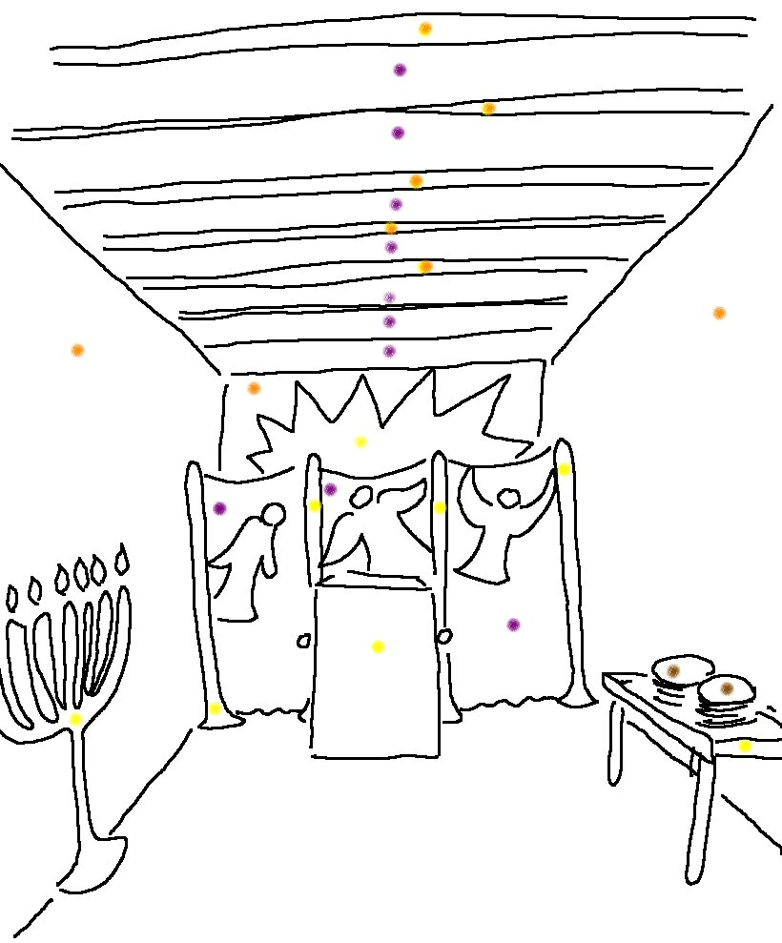
Have the people of Israel build me a holy sanctuary so I can _ _ _ _ _ _ _ _ _ _ _ _ _.
Exodus 25:8_{NLT}

